
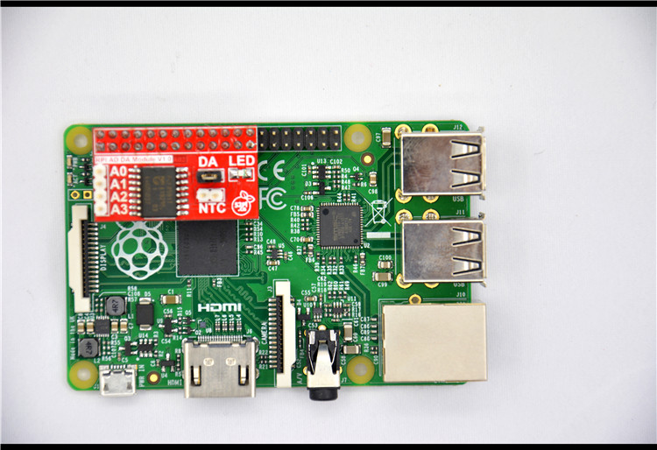

Raspberry Pi Expansion Module
User Manual

52PI-RPI-AD/DA
Maximum Power at Minimum Size
www.52pi.cn
Raspberry Pi AD/DA Expansion Module User Manual

Contact Us
Raspberry Pi Geek Forum

admin@52pi.net
www.52pi.cn

Version：1.0
Data：2014.9

Directory
1:Product Specification： 6
2:Produce Overview： 6
3:Produce Features： 6
4:Port： 7
5:Product Parameters： 7
6:Typical Application： 7
7:How to use： 7
8:More information： 8
8.1:D/A conversion sequence： 9
8.2:A/D conversion sequence： 9
9:Version 10

Raspberry Pi Geek Forum Copyright Statement：
The document only descript the information about product however. It can not be guarantee the product function and performance. If the document content or the product feature and tech spec included document be changed, it will be not further notice.

Content in the document might past due. Our cooperation can not promise update these information.

Some information in the document might disable in your local area, that include product and service. You can consult with contact and agency in your local area.

Copyright to the document belong to Raspberry Pi Geek Forum. User only can use these content after he or she get authorization from our company or other obligee. However user can not copy paraphrase or creative similar device or product.

The document final right to interpret and document be used final interpret belong Raspberry Pi Geek Forum

More information:
Get more product and support, please contact Raspberry Pi Geek Forum(www.52pi.cn)

Attention:

Due to technical requirements components, please do not hand directly connected
Touch. Core board and development system contains static-sensitive devices. Quiet Electrical charge easily accumulate in the human body and the device can not detect possible Damage to equipment, it is recommended to take anti-static measures, it is recommended not to hand. Touch, stored in anti-static effect devices.

Raspberry Pi Expand Module Serial：

Infinity cascade IO expand module：
This module is designed specifically for the Raspberry Pi IO expansion modules. The module expand 32 IO, Multiple modules can cascade, infinity cascade，infinity GPIO.

I2C GPIO expand module：
This module is designed specifically for the Raspberry Pi IO expansion modules. The Module use I2C bus to connect to Raspberry Pi. The module expand 8 Bidirectional GPIO and wit isolation protection function which can effectively excessive external voltage. There are 8 I2C address, you can choose one of them through setup the jumper. Multiple modules can cascade and maximum cascade 8 modules!

Prototype development module：
The Prototype development module is designed specifically for the Raspberry Pi. The module suitable enthusiasts and user can weld peripheral to the module；The module expand some amphenol connector and some SMT, so the user can finish prototype test easily.

Berryclip expand module：
The BerryClip module is designed specifically for learning how to use the GPIO of Raspberry Pi. There are 6 multiple color LED, 1 button and 1 Buzzer on the module.

Berryclip(DIY) expand module：
The module is not the end product, you need weld them by yourself. The function of the module is the same as BerryClip module.

UNO compatibility module：
The module makes Raspberry Pi compatible with Arduino Uno and many Arduino Shields. The module’s GPIO is the same as Arduino Uno and you can choose the voltage of GPIO between 5V or 3V through setup jumper.

T Electric level convert module：
The module expand the GPIO of Raspberry Pi to breadboard. It convert 3.3V electric to 5V electric level, then the Raspberry Pi can connect many 5V electric level peripheral.

IO extraction module：
The module expand all of GPIO of Raspberry Pi to breadboard.

RTC expand module：
The RTC module is specifically designed for Raspberry Pi. There is a 0.2uF SuperCapacitor on the board to keep the real time for a long time after the Raspberry Pi has power off.

AD/DA expand module：
The AD/DA module is specifically designed for Raspberry Pi. There is 8bit high resolution DAC and ADC on one chip.

I2C electric level conversion expand module：
The I2C electric level conversion module is specifically designed for Raspberry Pi. The module convert the 3.3V of I2C electric level to 5V level or convert 5V to 3.3V.

I2C electric level conversion expand module：
The Serial Por module is specifically designed for Raspberry Pi. The module use Maxim MAX232 chip and DB9 port. So the user don’t need to connect Dupont Line and that avoid wrong wiring. User can use this module to debug Raspberry Pi easily.

1:Product Specification：
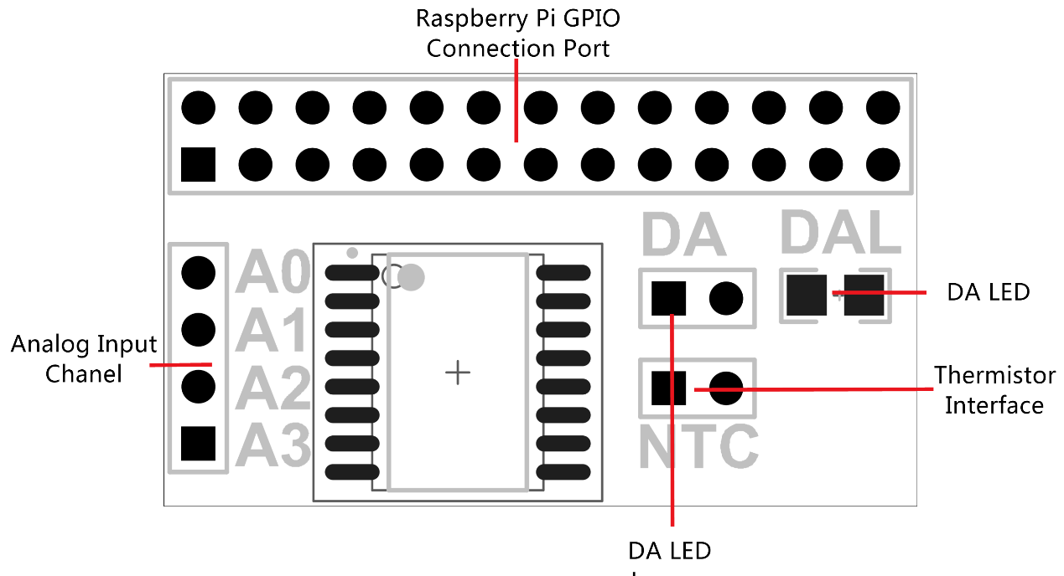

2:Produce Overview：
The DA/AD module is specifically designed for RaspberryPi. It communicated with RaspberryPi through I2C bus. There is a LED light on the board that you can adjust brightness through DA. The module supply 4 ADC channel through header on the left side of module and the thermistor interface. The user can choose according to actual demand and use them. The module is easy to use even you don’t need to write C code. Because the module support wiringPi so you can use shell script to control it.

3:Produce Features：
- Use PCF8591T chip
- DA/AD in one module
- 8bit high resolution DA/AD
- Compatible with wiringPi
- Supply thermistor and photoresistance

4:Port：
- Raspberry Pi connection port
- Thermistor interface
- 4 external analog channel
- Electric level switch jumper
- LED of DA choice jumper

5:Product Parameters：
- Working voltage: 2.5V-6.0V
- 8-bit successive approximation A/D conversion
- Multiplying DAC with one analog output
- Analog voltage range from Vss to VDD
- 4 analog inputs configurable as single ended or differential inputs
- Max sampling rate given by I2C-bus speed
- −40°C to +85°C operation

6:Typical Application：
- Supply monitoring
- Reference setting
- Analog control loop

7:How to use：
Just insert the module to Raspberry Pi, like the below picture：
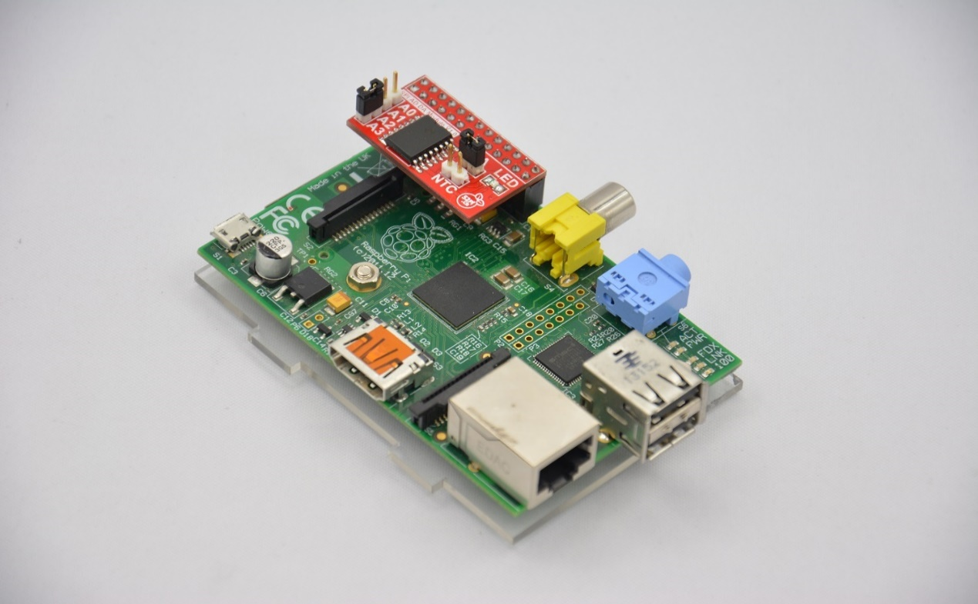

8:More information：
The PCF8591 is a single-chip, single-supply low-power 8-bit CMOS data acquisition
device with four analog inputs, one analog output and a serial I2C-bus interface. Three address pins A0, A1 and A2 are used for programming the hardware address, allowing the use of up to eight devices connected to the I2C-bus without additional hardware. Address, control and data to and from the device are transferred serially via the two-line bidirectional I2C-bus.
The functions of the device include analog input multiplexing, on-chip track and hold
function, 8-bit analog-to-digital conversion and an 8-bit digital-to-analog conversion. The maximum conversion rate is given by the maximum speed of the I2C-bus.

8.1:D/A conversion sequence：
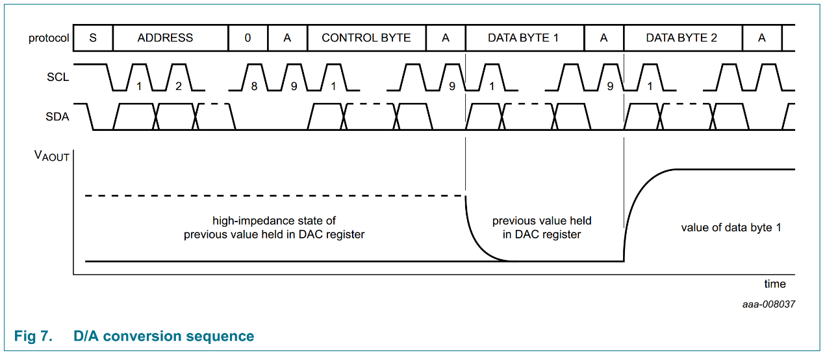

8.2:A/D conversion sequence：
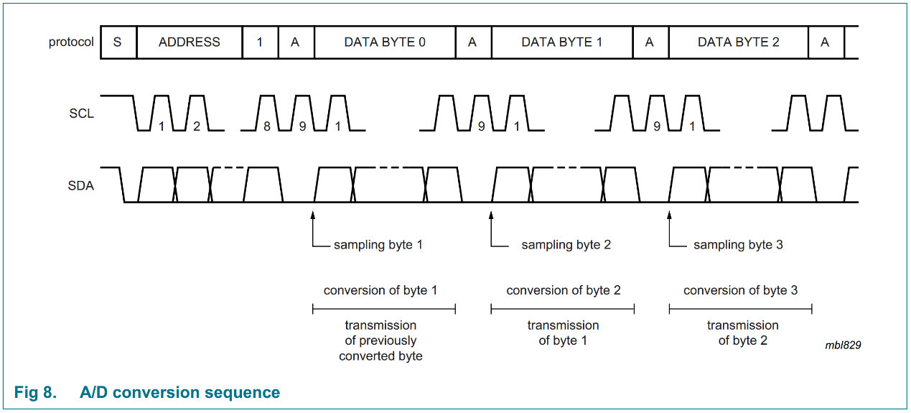

8.3:Schematic diagram：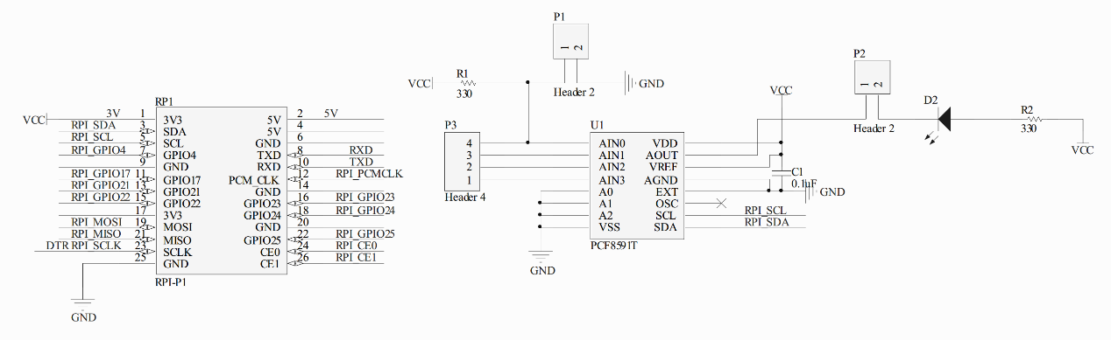

More information please check：
http://www.nxp.com/products/interface_and_connectivity/i2c/i2c_dacs_and_adcs/PCF8591T.html
8.4:TestBench：
Please Check：http://www.52pi.net/forum.php?mod=viewthread&tid=984&fromuid=2113

9:Version
Version | Date | Document Version
52PI-RPI-AD/DA | 2014-09-23 | 52PI-RPI-AD/DA V1.0

